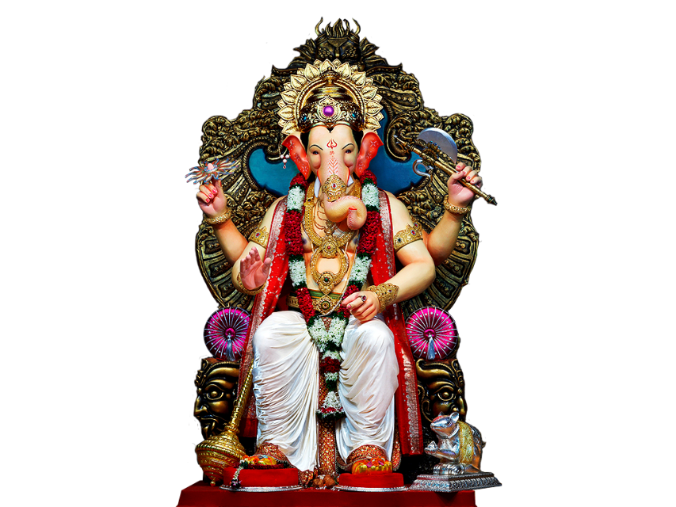

This Photo by Unknown Author is licensed under CC BY-NC
30% discount on any items and free Delivery on

Ganesh Chaturthi
Discount on type of items and cloths

This coupon is also available in Amazon, Flipkart, Myntra
Coupon no:653289784511
To: 9 September
Form:20 September
A SPECIAL MOTHER’S DAY

Gift for you
THIS GIFT ENTITLES YOU TO
$50 to Foxtail Bakery
To: Mom
Love: Jack

